OTHER PUBLICATIONS

BOOKS :
1. ‘Approaches to Common Sexual problems in Medical practice’, Dr. T.S.S.Rao & Dr.Vasumathy S. Rao. released at III Karnataka State Level Conference at Shimoga on 12th Sept. 1993 (Second Edition, Published in 2001)
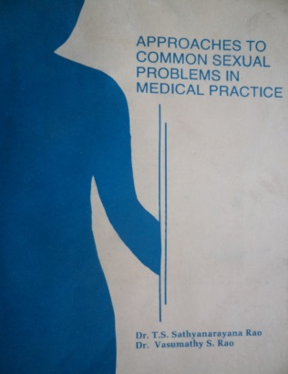

2. Part contribution to psychology/psychiatry section in ‘Kannada Medical Encyclopedia’ under editorship of Dr. P.S. Shankar, Kannada University, Hampi.

3. Shivayoga & Psychology Chapter in the book ‘Shivayoga’ (Kannada). [2001] Publisher : J.S.S. Mahavidyapeetha, Mysore.
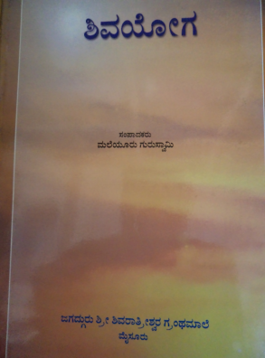
4. ‘Manual on Sex Education for Secondary School Teachers’, [2000] NCERT New Delhi,

5. “Dampathya Vaidya Shastra”. A book in Kannada on Sexual Medicine. (384 pages). By Dr.T.S.S.Rao Publisher: Kannada Vaidya Sahithya Parishat,Mysore. (Second Edition)
Won Kannada Vaidya Sahitya parishad award for most popular book & is the source book for Kuvempu University, Shimoga for M S Sexual Counseling course.
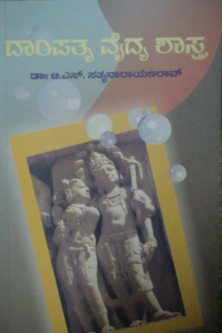

6. Handbook of Common Sexual Problems, [1998] Ed. Dr.Raj Bramhabhat. Co-author & Member Editorial Board, Pub: Family Planning Association of India, Mumbai.
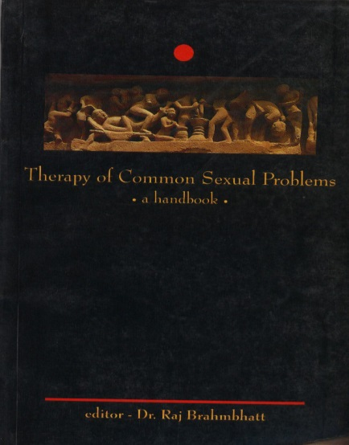

7. Chapter on “Sexual Methods” [2005] in Comprehensive Text Book of Sexual Medicine, edited by Nilamadhab Kar and Gopal Chandra Kar, published by Jaypee Publishers Pvt Ltd., New Delhi, The second edition 2013, in print.
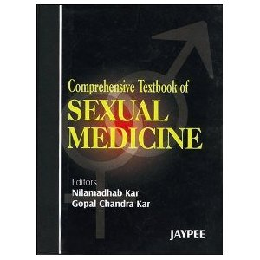

8. Chapter on “Premarital Sex” [2005] (Vivahapoorva Laingika Sambhoga – Saadaka Baadhakagalu) in the book “Srishti”, published by Dr. Leelavathi Devada Abhinandana Grantha,

9. Clinical Practice guidelines on Sexuality Practice, official publication of Indian Psychiatric Society.

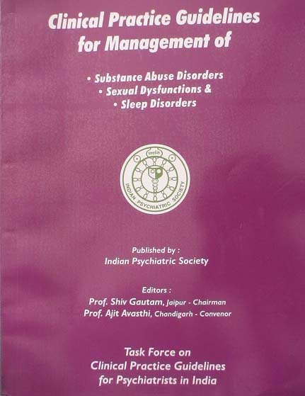

10. Commemorative Volume of Indian Journal of Psychiatry, released in Kolkata at ANCIPS 2008, 516 page compendium.

11. Medical encyclopedia, Mysore University, work under way.

12. “Laingika Shakthi Matthu Arogya” [2010] Kannada published by Karnataka Sexual Academy.
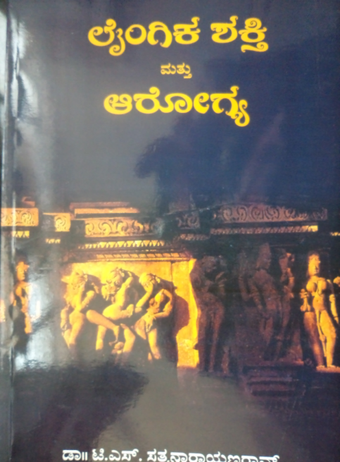

13. “Laingika Jeevana” [2010] Kannada published by Karnataka Sexual Academy.

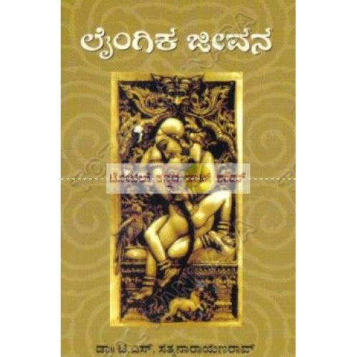

14. “Vaidya Sahithya – Samrudha Arogya”[2009] Contributory Author, Kannada Vaidya Sahithya Parishad,

15. “Indian Research in Psychiatry: A Journey of Six decades” a compendium of 970 pages covering all the research in Indian Psychiatry. Published by Indian Journal of Psychiatry / Indian Psychiatric Society.

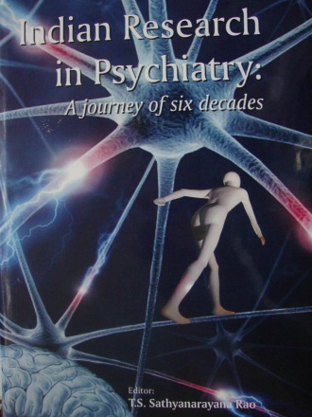

16. “Psychiatry in India: Training and Training Centers” Revised Edition a reference text released at ANCIPS 2015 at Hyderabad. “Psychiatry in India: Training and Training Centers” Second Edition a reference text released at ANCIPS 2016 at Bhopal

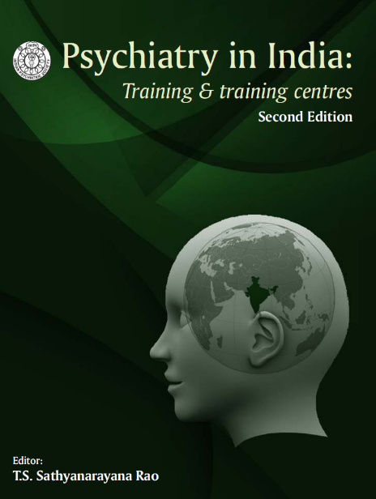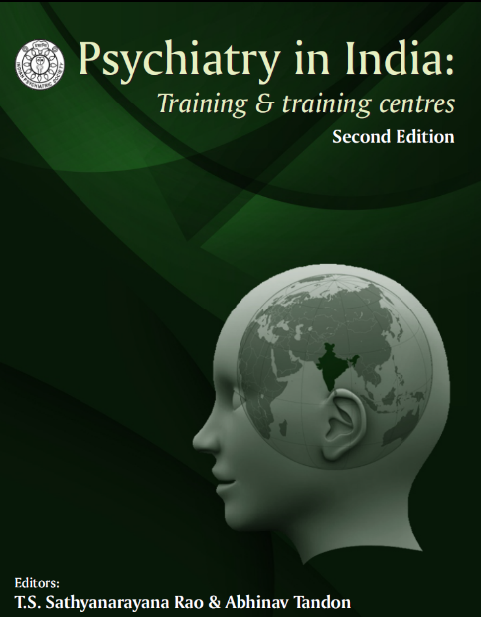

17. The book “The Art of Psychiatry: Relationship Matters” edited along with
Dr. Prasad Rao. G. as a supplement of Indian Journal of Private Psychiatry released, July 2011.

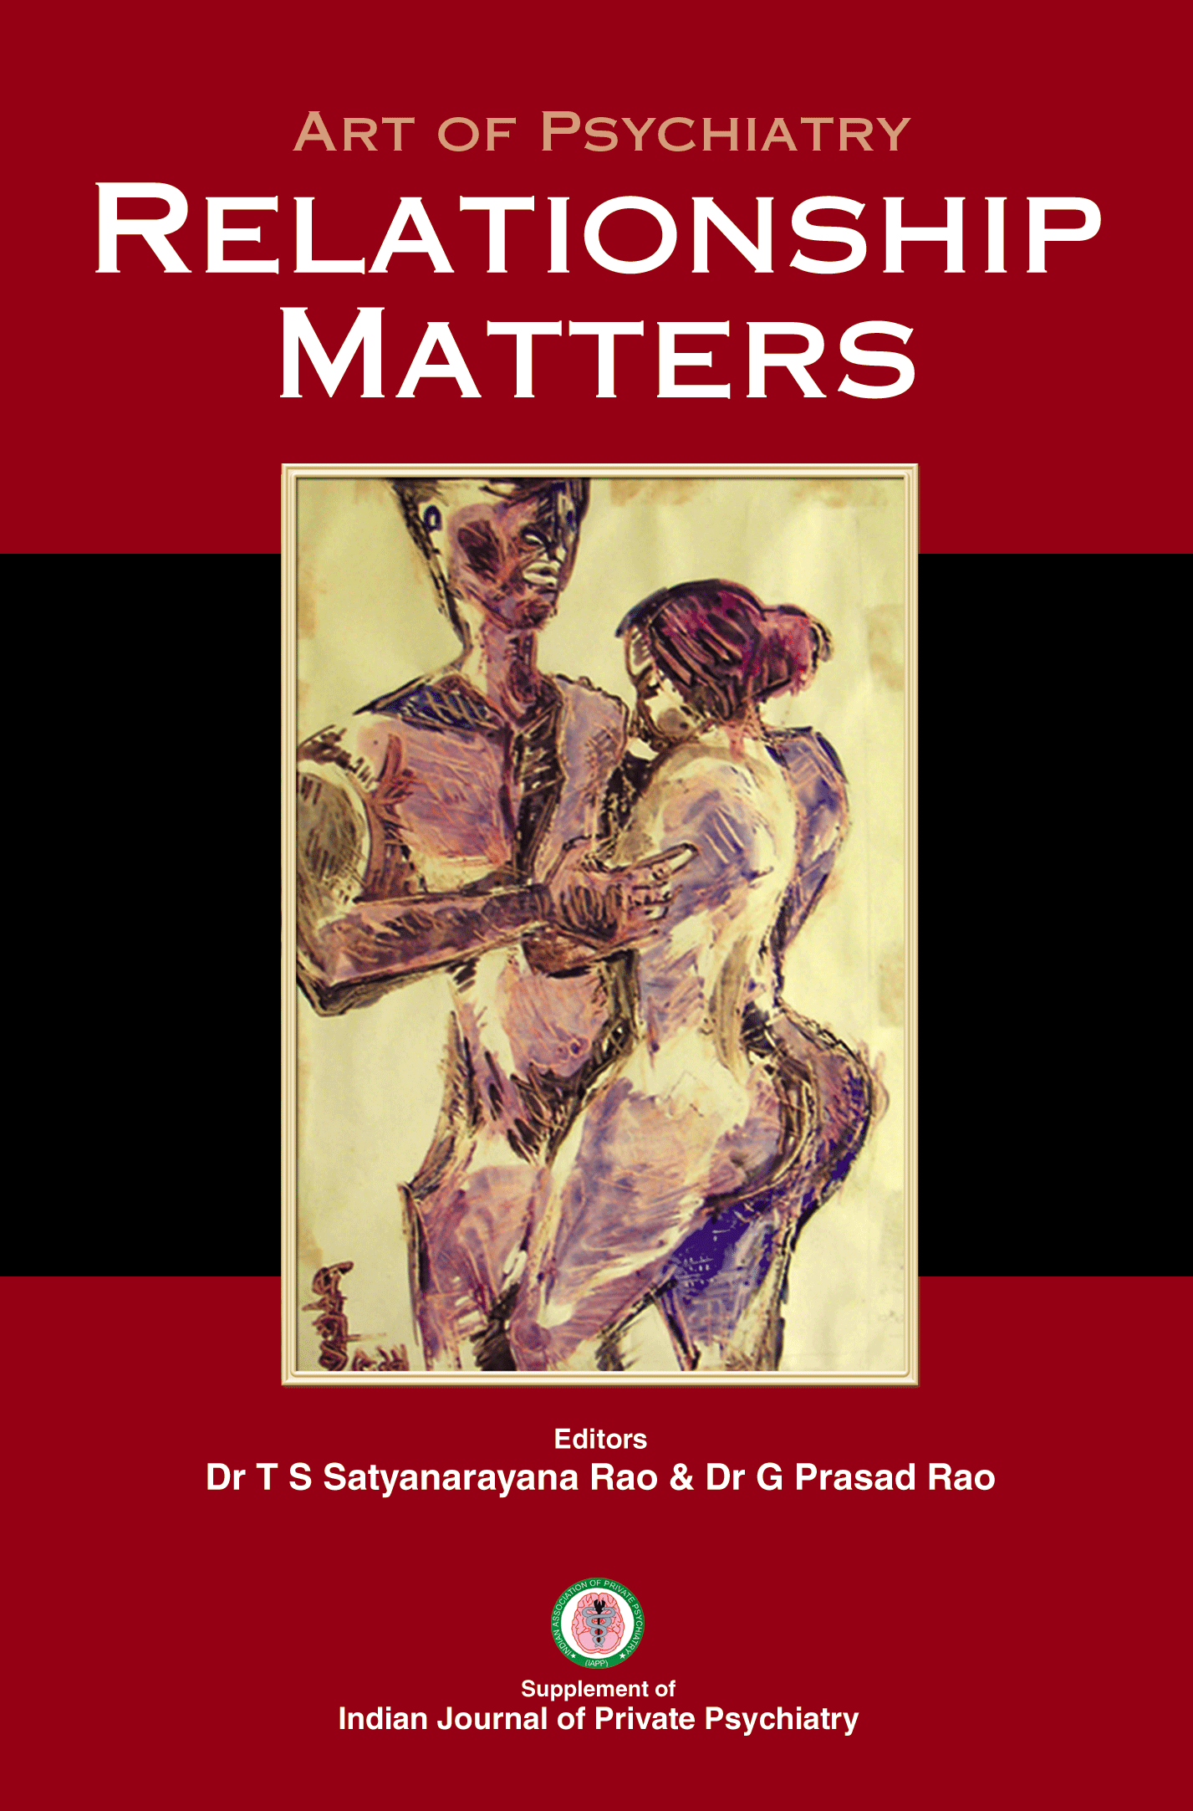

18. The book “Intimacy Matters: Elderly Sexuality” edited with Dr. Sanjay Gupta and Dr. Abhinav Tandon. The Official Publication of Indian Association for Geriatric Mental Health released, Sept 2011.

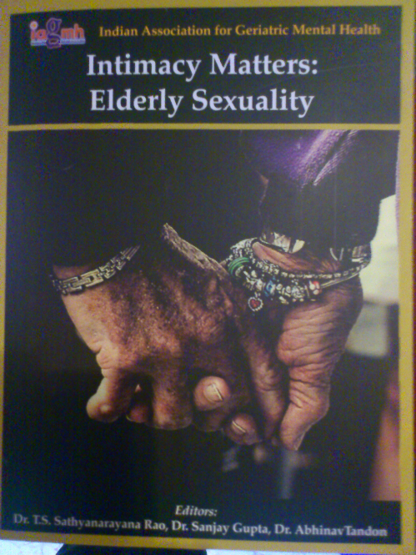

19. The book “Career planning for Young Psychiatrists: What you don’t learn at College” edited by Sathyanarayana Rao T.S, Vishal Indla, Indla Ramasubba Reddy, as a special supplement for Young Psychiatric Forum released at Aug 2012

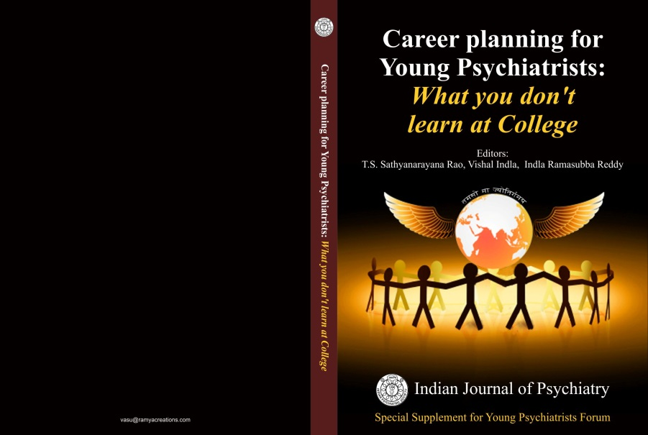

- The book “Indian Mental Concepts – I” edited by Sathyanarayana Rao TS, L Sam S Manickam, Roy Abraham Kallivayalil, as a special supplement Vol. 55, January 2013, released at ANCIPS 2013, NIMHANS, Bangalore.
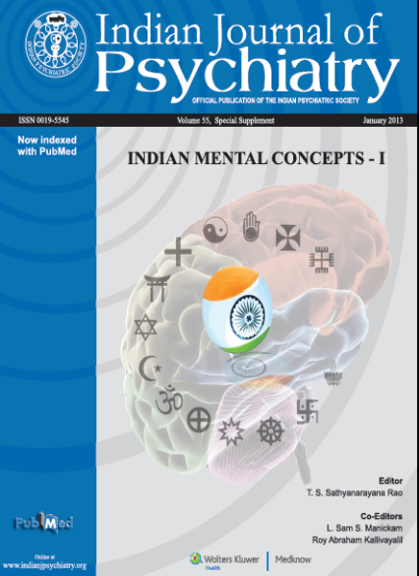

- The Abstract Book Volume 57, supplement January 2015; released at ANCIPS 2015 at Hyderabad. Every ANCIPS Abstract book is published as a special supplement

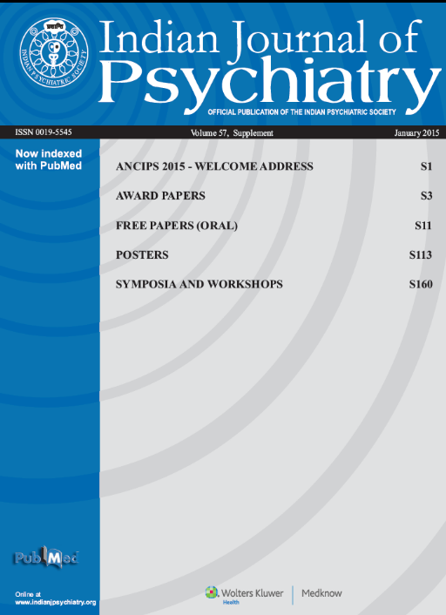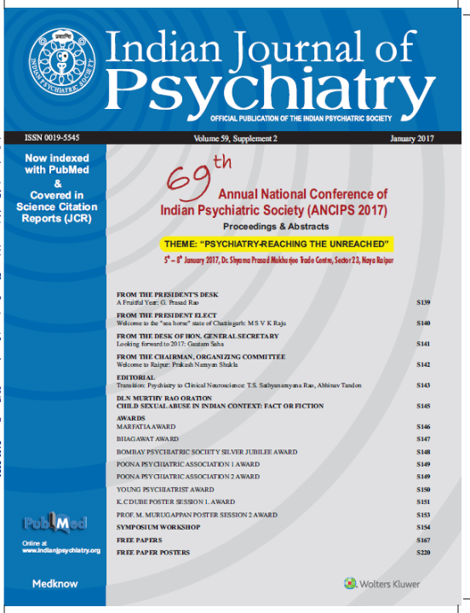

- The Book Special Supplement – Vol 57, Supplement 2, July 2015: Women Mental Health: Reflection from India, Guest Editors: Dr. Indira Sharma and Abhishek Pathak; released at National Midterm CME, Nagpur

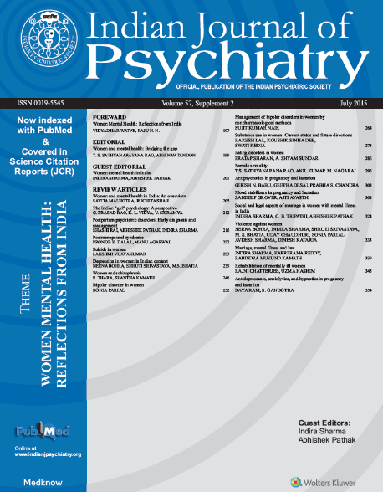

- Indian Psychiatric Society Clinical Practice Guidelines Revised Edition 2016
Editor: T S Sathyanarayana Rao
Guest Editors: Dr. Shiv Gautam, Ajit Avasthi, Sandeep Grover

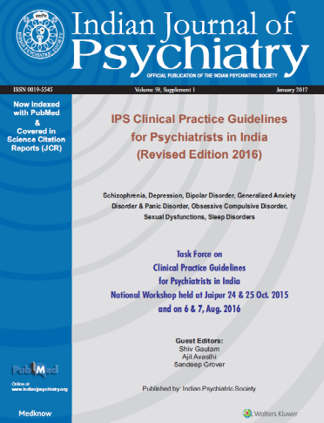

- A Special Supplement on Forensic Psychiatry, carrying proceedings and abstracts from IALMH Asia Pacific Conference, Bangalore. Dr. Ganeshan Gopal Krishnan from MVJ Medical College, Bangalore was the Guest Editor.

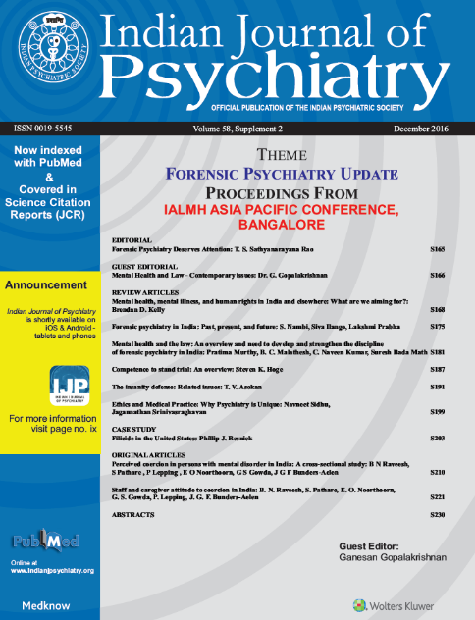

  - A Special Supplement – 1 on CLINICAL PRACTICE
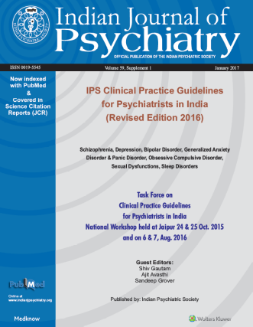
GUIDELINES , Guest Edited by Dr. Shiv Gautam,
Dr. Ajit Avasthi and Dr. Sandeep Grover. This carried
the proceedings of the Task force on Clinical Practice
Guidelines 2015 & 2016 covering 7 Major Mental
illnesses / Behavioral problems - Schizophrenia,
Depression, Bipolar Disorder, Generalized
Anxiety Disorder & Panic Disorder,
Obsessive Compulsive Disorder, Sexual
Dysfunctions & Sleep Disorders.
This is accessible vide the link
https://www.sendspace.com/file/eq46rd
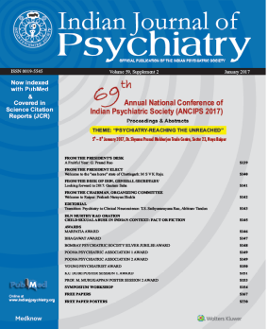

  - The Special Supplement – 2 January 2017
carrying proceedings and Abstracts of
ANCIPS 2017 at Raipur was available online https://www.sendspace.com/file/06320h

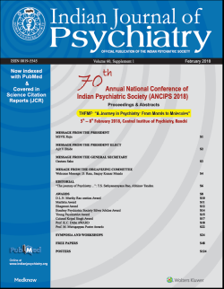

- SPECIAL PUBLICATIONS FOR 2018.
  - The Special Supplement – 1 January 2018
carrying proceedings and Abstracts of
ANCIPS 2018 at Ranchi was available online
http://www.indianjpsychiatry.org/currentissue.asp and also at
https://www.sendspace.com/file/m5fqbh

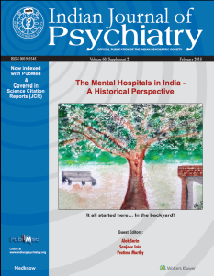

  - A Special Supplement – 2, 2018 “The Mental Hospitals in India –
A Historical Perspective”
Guest Editors, Alok Sarin, Sanjeev Jain, Pratima Murthy.
ANCIPS 2018 at Ranchi was available online
https://www.sendspace.com/file/m5fqbh

  - A Special Supplement – 3, 2018 on IPS CLINICAL PRACTICE
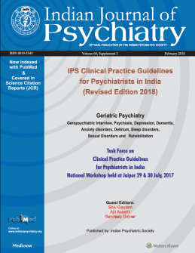
GUIDELINES for Psychiatrist in India Revised Edition 2018 ,
covering Geriatric Psychiatry: Psychosis, Depression, Dementia, Anxiety Disorders, Delirium, Sleep Disorders, Sexual Disorders and the Rehabilitation.
Guest Edited by Dr. Shiv Gautam, Dr. Ajit Avasthi and
Dr. Sandeep Grover.
This is accessible vide the link
https://www.sendspace.com/file/m5fqbh

  - The Special Supplement – 4, 2018 Guidelines for
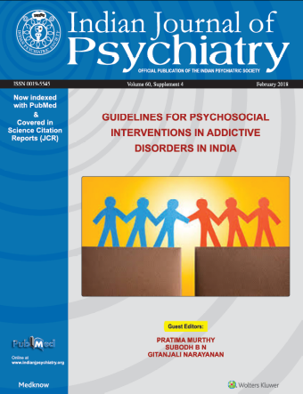
Psychosocial Interventions for Addictive Disorders
In India,
Guest Editors: Pratima Murthy, Subodh BN,
Gitanjali Narayan
ANCIPS 2018 at Ranchi is available online https://www.sendspace.com/file/m5fqbh

Supplements 2,3 and 4 will be web hosted on
5th / 6th February 2018

New Journal Launch January 2019
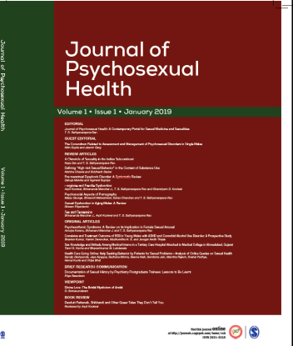
Journal of Psychosexual Health (JPSH)
Editor: Dr. T.S. Sathyanarayana Rao
Publisher: Sage Publication India Pvt. Ltd., New Delhi.
http://journals.sagepub.com/home/ssh

Important & Selected Book Chapters:

- Community Psychiatry in India: Publication committee; IPS; 2013;Sathyanarayana Rao, Abhinav Tandon; Sexual Disorders; Community aspects; 106-142
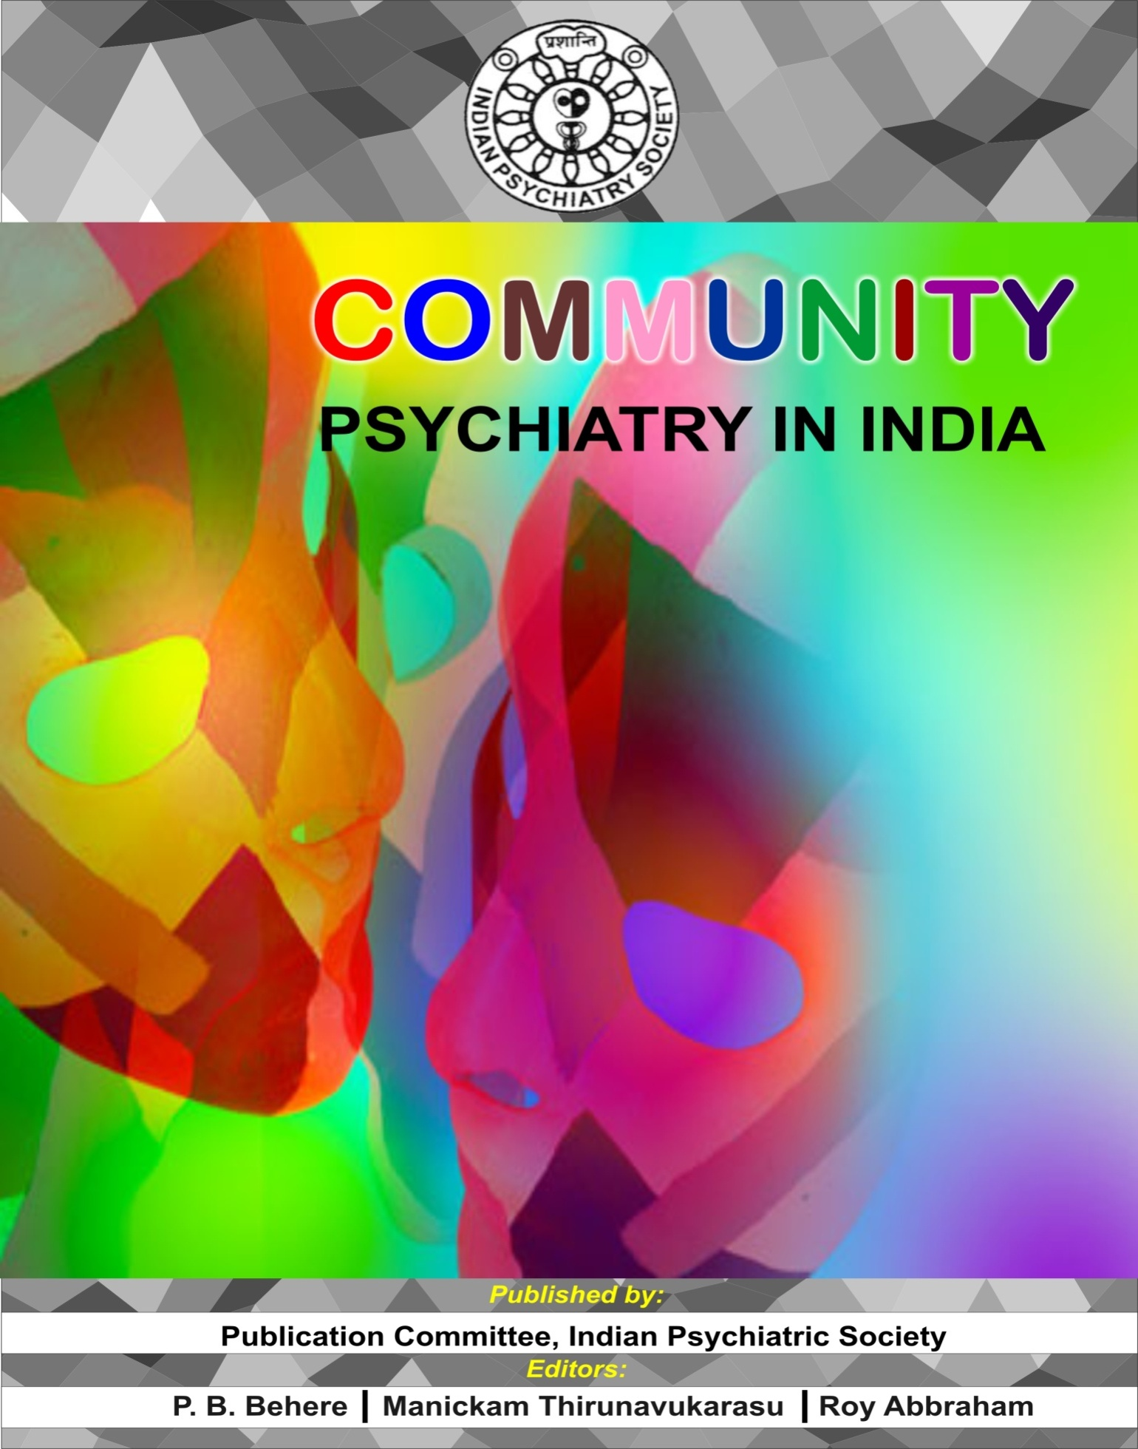

- API Text Book of Medicine, Editor in Chief, YP Munjal, 10th Edition, Sexual Disorders; T.S. Sathyanarayana Rao, Abhinav Tandon ch. Title Sexual Disorders; Association of Physicians India; Edn 10; Vol 1 & 2; 2266-2275

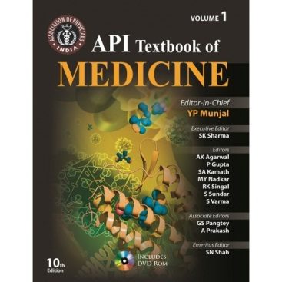

- Essentials of Postgraduate Psychiatry, Paras Medical Publisher 2nd Edition; Edited by JN Vyas, Shree Ram Ghimire

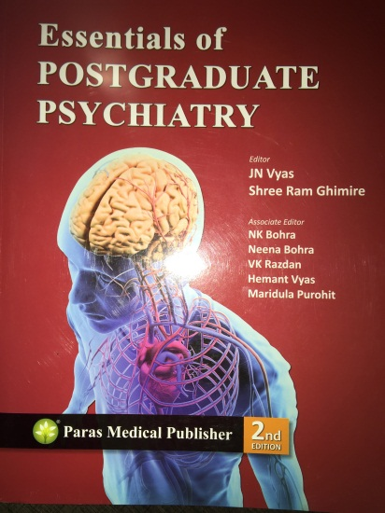

- Comprehensive text book of Sexual Medicine; Sathyanarayana Rao T S, Abhinav Tandon; Sexual Methods; (2014);111-124.
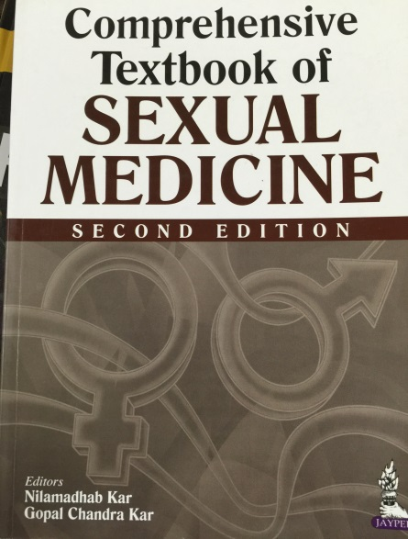

- Essential of Psychiatry for Obstetrics & Gynecology Practitioners; T.S. Sathyanarayana Rao; Approach to Male Sexual Dysfunction - 2015; 24 – 32.

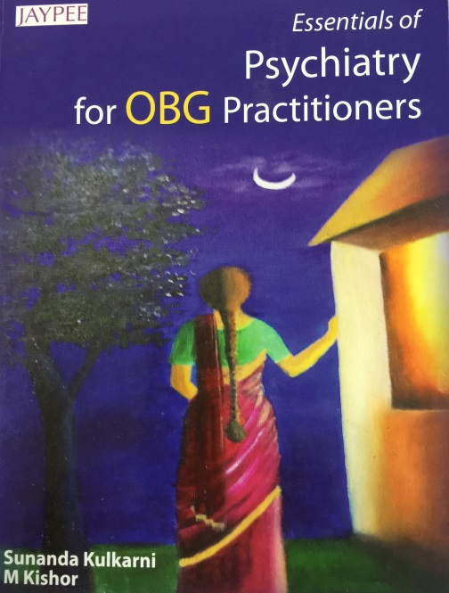

- Text book of Postgraduate Psychiatry Ed: JN Vyas, Shree Ram Ghimire T.S. Sathyanarayana Rao, Abhinav Tandon; Normal Human Sexuality and Sexual Disorders; 2016; 685 – 700

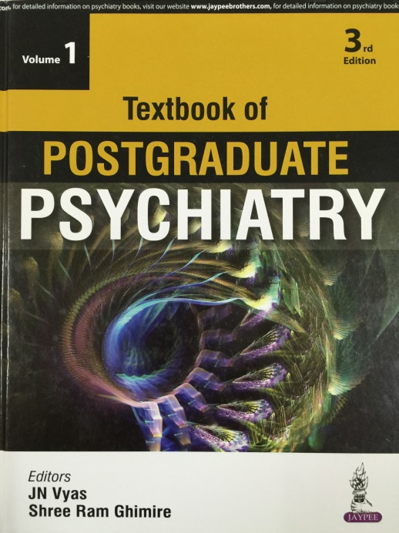

- “ Book Release Function & Mental Health Symposium” on 20 August 2016, Saturday at Swami Vivekananda Rangamandira, P.E.S. College Campus, M.C. Road, Mandya.
Introduction to Book was by Dr. Anil Kumar, Principal, PES Science, Arts & Rao. Introduction to Book was by Sri N. Vishwarupachar, President, Kannada Vaidya Sahithya Parishath.

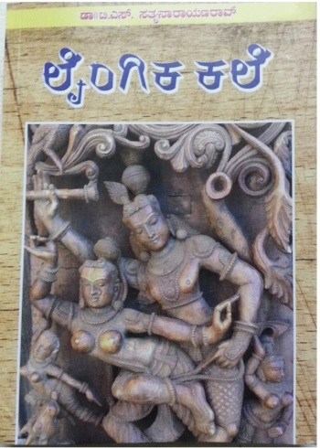

- Different Strokes: Interfaces of Psychiatry Edited by Dr. Vinay Kumar for IPS
Chapter: Interface with Sexuality – 42 -53

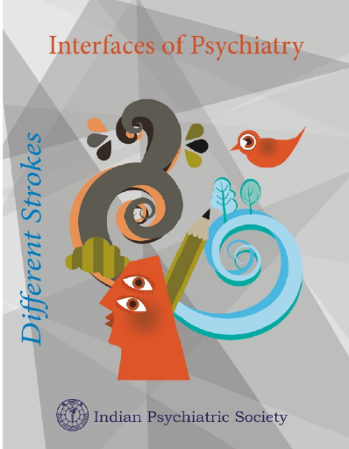

Different Strokes: Interfaces of Psychiatry Edited by Dr. Vinay Kumar for IPS
Chapter: Interface with Sexuality – 42 -53
Different Strokes: s of Psychiatry Edited by Dr. Vinay Kumar for IPS
Chapter: Interface with Sexuality – 42 -53

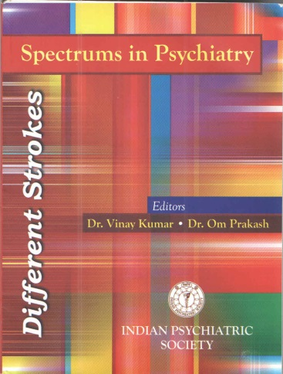
Different strokes: Spectrum in Psychiatry, Editors; Dr. Vinay Kumar, Dr. Om Prakash, for IPS; Chapter: Sexual Orientation Spectrum 22 - 25.

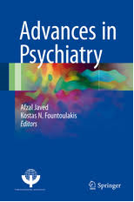
Advances in Psychiatry Ed. Afzal Javed, Kostas N. Fountoulakis. For World Psychiatric Association; Mental Health and Sexaul Medicine: An update; Springer International Publishing AG; Advances in Psychiatry; 2019:347-371

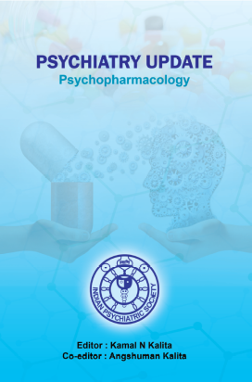
Psychiatry Update: Psychopharmacology; Edited Kamal N Kalita & Angshuman Kalita of Indian Psychiatric Society; Pharmacotherapy of Sexual Dysfunction; Shivananda Manohar J, Abhimanyu Chandak, T S Sathyanarayana Rao- 2018; 133 – 148.

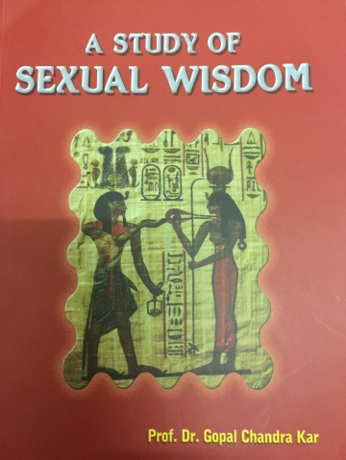
A Study of Sexual Wisdom; Edited by Prof. Dr. Gopal Chandra Kar, Published by United Book House; Sexual Methods; T S Sathyanarayana Rao- 2017; 175 – 194.

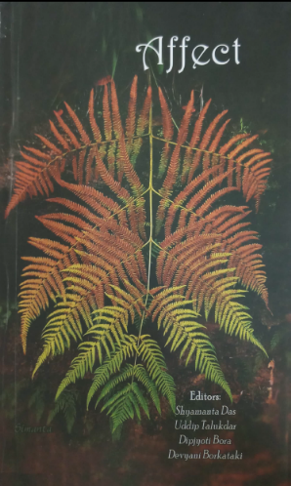
Affects; Edited by Dr. Shyamanta Das etal , Published by SOMHIL; Suman S Rao, Shivanand Manohar, Ajay Solanki, T.S. Sathyanarayana Rao; Treatment emergent sexual dysfunction in bipolar disorders; 2019; 81-114

Affects; Edited by Dr. Shyamanta Das etal , Published by SOMHIL; Shivanand Manohar J, Suman S Rao, Abhimanyu Chandak, T.S. Sathyanarayana Rao; Bipolar Disorders and Sexuality; 2019; 61-80.

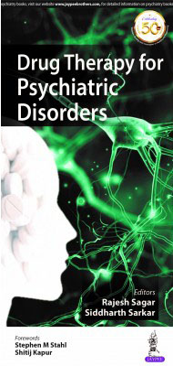
Drug Therapy for Psychiatric Disorders:Edited by Rajesh Sagar, Siddarth Sarkar; Published by Jaypee Brothers Medical Publishers; First Edition 2020; Shivananda Manohar J, T.S. Sathyanarayana Rao; Treatment of Sexual Dysfunction; 2020; 67 – 80.

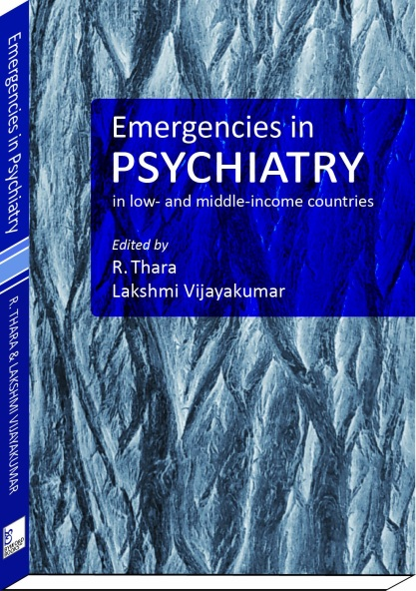
Emergencies in Psychiatry :Edited by R Thara, Lakshmi Vijayakumar; Published by By words Books; First Edition 2012; T.S. Sathyanarayana Rao, Gurvinder Kalra; Sexual Emergencies; A Psychiatrist;s perspective; 2012; 124-135.

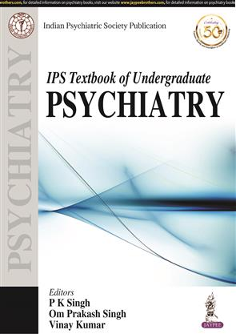
IPS Text book of Undergraduate Psychiatry Ed:
PK Singh, Om Prakash Singh, Vinay Kumar
Shivananda Manohar, T.S. Sathyanarayana Rao, Abhinav Tandon; Shreemit Maheshwari, Suhas Chandran, Normal Human Sexuality and Sexual Disorders; 2021; 184 – 197

IPS Publication: Cyberpsychiatry Ed. Sudhir Bhave, Co-Ed. Sushil Gawande; Debanjan Banerjee, Vyjayanthi N Ventakaramu, T.S. Sathyanarayana Rao; Utilizing cyberspace for Tele-mental health services: overview.

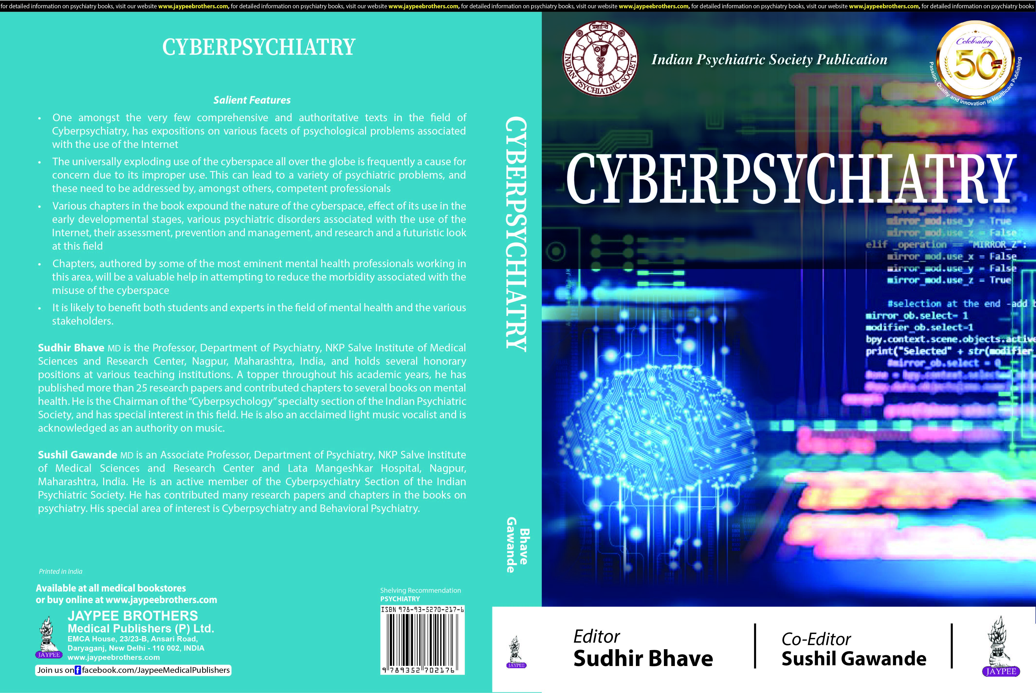
IPS Publication: Cyberpsychiatry Ed. Sudhir Bhave, Co-Ed. Sushil Gawande; Vyjayanthi N Ventakaramu, Debanjan Banerjee, T.S. Sathyanarayana Rao; Future of Cyberpsychiatry: The paths Ahead.

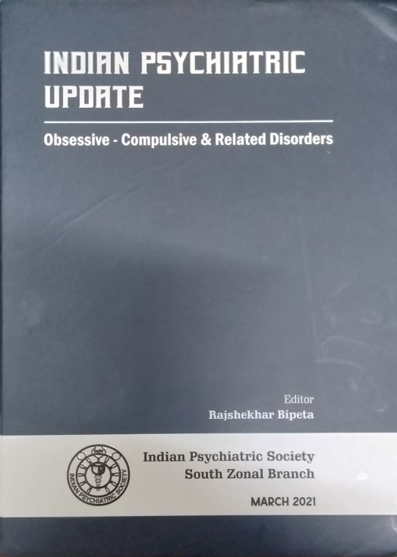
Indian Psychiatric Update – Obsessive compulsive & Related Disorder Ed. Rajshekhar Bipeta, IPS South Zonal Branch March 2021; Abhinav Tandon, Debanjan Banerjee, T S Sathyanarayana Rao; Comorbidities in Obsessive Compulsive Disorder; IPS S-Z; 2021; 27-42

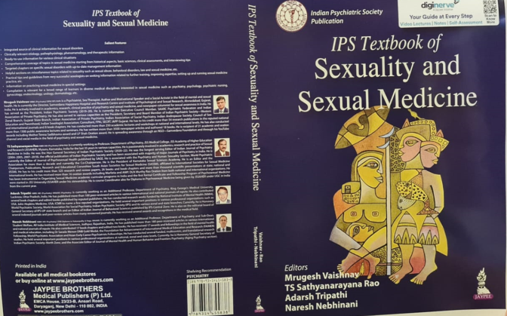
IPS TEXT BOOK OF SEXUALITY AND SEXUAL MEDICINE - from Indian Psychiatric Society -1st Edition (2022) Edited by Dr. TSS Rao, Mysore along Dr. Mrugesh Vaishnav, Ahmedabad, Dr. Adarsh Tripathi, Lucknow
& Dr. Naresh Nebinani, Jodhpur.

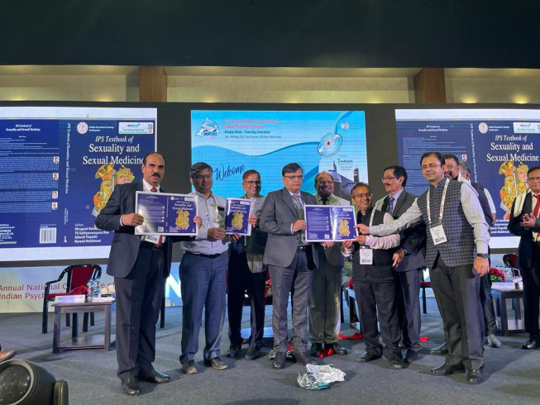

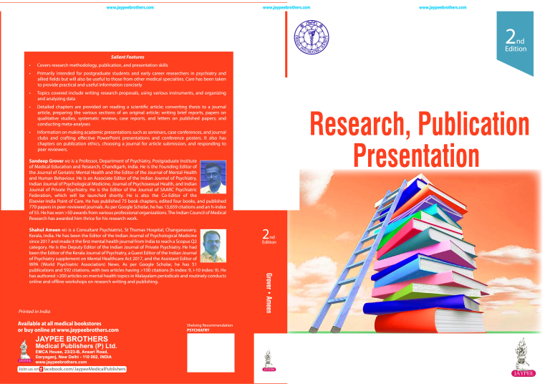
A Primer of Research, Publication and Presentation 2nd Edition - IPS Publication.
'How to select a Journal to publish an article' by Dr TSS Rao & Dr Abhinav Tandon – 350-361;

